WEEKEND PLAN

Friday, 2 February 2023
Travel to Oudtshoorn
Discount at Spur for supper the evening
Saturday, 3 February 2024
07.00 Proceed to De Jager Sports Complex (extra parking via St Johns Road)
07.25 Compulsory Team meeting at De Jager Sports Complex – 100m mark –(please inform Gerhard 082 808 1106 if you cannot be at the team meeting)
WP Team and supporters sit on top right hand side of pavillion. Function tickets will be handed out – 100m mark on track
07.40 March-past
07.45 Opening
08.15 First running item
10.30 Warm-up at N.A. Smit Pool (pool will be open from 10:00)
Swimming starts (as soon as possible after running)
18.15 Proceed to Highgate Ostrich Farm
18.45 Take seats for prize giving
19.00 Prize-giving, dance & Braai (Dress code: casual)
23.59 Last dance

PLEASE NOTE THAT TIMES FOR SATURDAY ARE SUBJECT TO CHANGE. ATHLETES WILL BE NOTIFIED AT THE TEAM MEETING.

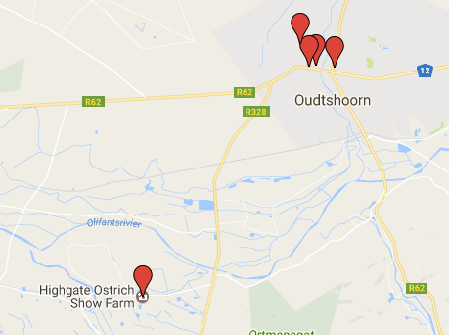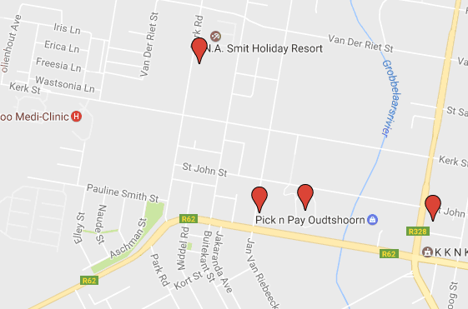

Highgate Venues in Oudtshoorn

