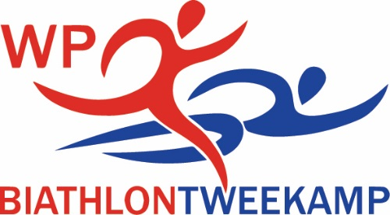

MINUTES OF THE ANNUAL GENERAL MEETING AND PRIZE GIVING OF THE WESTERN PROVINCE BIATHLON ASSOCIATION 202
At 18.00
ZOOM meeting

Welcome
Gerhard Louwrens open en welcome all present at this first ever virtual WP AGM. Also a special word of welcome to Johan Ferreira, secretary of the SA Biathlon and the committee members of WP Biathlon.

Present
See attached list

Chairmans report
See attached the chairmans report for the 2020 season with the following:
- Highgate Interprovincial
- National Championships
- Growth in athletes numbers
- Challenges 2021 season
- Schools competition
- Committee
- Word of thanks

Financial report 30 April 2020
Ernst van Schalkwyk, the treasurer, present the financial report for 2020 as well as the budget for 2021.

Affiliation fees 2020/2021
- First family member R380.00
- Second family member R320.00
- Third family member R200.00
- Extra family members R100.00
- Visitors R 80.00
Payment before 31 October 2020 R50 discount.

Selection of the committee 2020 / 2021
- Chairman Gerhard Louwrens
- Vice chairman Marco Prinsloo
- Secretary Esrie Loock Bezuidenhout
- Treasurer Ernst van Schalkwyk
- Additional members Johan Ferreira
- Additional member Herman Ochse
- Additional member Christopher van Niekerk
- Additional member Rens Els
- Additional member Nick Thomatos

Prize giving :
Junior Victrix Ludorum Tatiana Thomatos
Junior Victor Ludorum Nathan van den Berg
Senior Victrix Ludorum Kate Bihl
Senior Victor Ludorum Michael Archer
Gianna Marais Wisseltrofee Tatiana Thomatos
The Stewart Cup Nathan van den Berg
Rix and Bass Floating Trophy Kate Bihl
Swanepoel-wisseltrofee Michael Archer
Van der Bergh Trophy Lize-Ahn Aucamp
WP Chairmans Trophy Ernst van Schalkwyk
WP Committee Merit Award Christopher van Niekerk
Eversdal Floating Trophy Durbanville Primary school
Sandra van Niekerk Memorial Trophy High School Stellenberg
Junior Male Athlete of the year Alshane Edwards
Junior Female Athlete of the year Tatiana Thomatos
Senior Male Athlete of the year Roger Bezuidenhout
Senior Female Athlete of the year Marna Louwrens

-------------------------------------------
Gerhard Louwrens
Chairman WP Biathlon

